SMUPS Home Learning Ideas: Week 1

Please find some more ideas for you and your family whilst learning from home. These are suggestions of resources that might help you structure and enliven the day…..
Phonics
www.phonicsplay.co.uk Username: march20 Password: home
www.phonicsbloom.com
www.lettersandsounds.com
www.bbc.co.uk/cbeebies/shows/alphablocks

Maths
https://whiterosemaths.com/homelearning/
Includes a Maths problem of the day and five films of Maths sessions a week for you and your child.
www.topmarks.co.uk
https://apps.apple.com/gb/app/bee-bot/id500131639
www.bbc.co.uk/cbeebies/shows/numberblocks
www.ictgames.c.uk
www.mathszone.co.uk
www.explorify.wellcome.ac.uk
www.prodigygame.com/
Story Time
www.oxfordowl.co.uk
www.vooks.com
www.classroommagazines.scholastic.com/support/learnathome.html
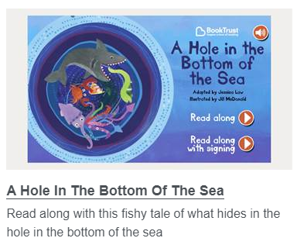
https://www.booktrust.org.uk/books-and-reading/have-some-fun/storybooks-and-games/

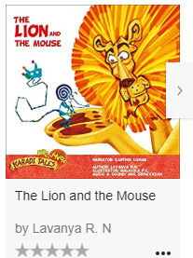

https://stories.audible.com/start-listen

Creative Development
Children have been painting rainbows and putting them in their windows all over the country, shall we cover South Molton in rainbows?
https://www.bbc.co.uk/news/uk-england-51988671
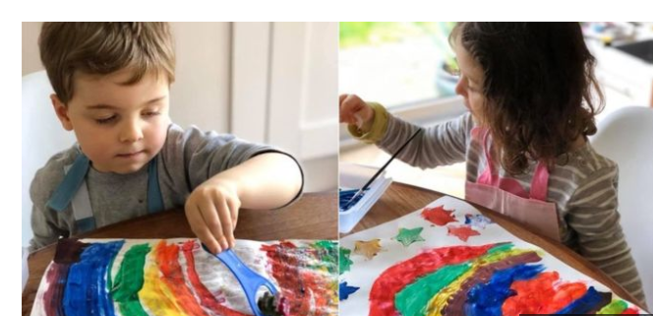
Including a survival guide for self-isolation and plenty of ideas for learning at home, including great recipes for messy play.
https://theimaginationtree.com/

Understanding the world
www.bbc.co.uk/newsround
https://www.travelandleisure.com/attractions/museums-galleries/museums-with-virtual-tours
For a virtual trips to galleries and museums from your home
Physical Development
www.plprimarystars.com
www.bbc.co.uk/teach/supermovers
www.youtube.com/user/cosmicKidsYoga
www.youtube.com/user/GoNoodlegames/featured

PSHE
https://www.mindheart.co/descargables
download a story about corona virus and how we are feeling about it, to share with your child.

