DISHES AND THEIR ALLERGEN CONTENT – Harbour Partnership Trust – Primary School – April to October Menu 2025
✓ Contains ✓ May Contain
 | 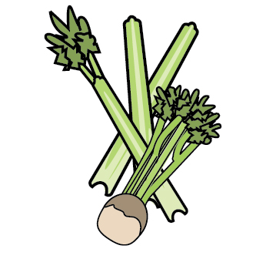 | 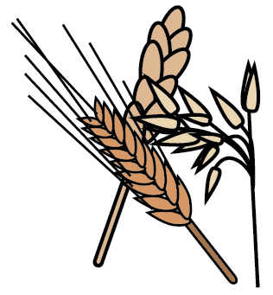 | 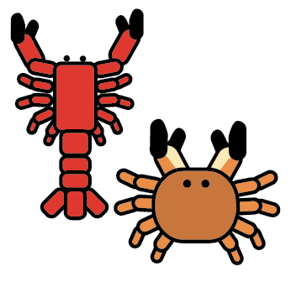 | 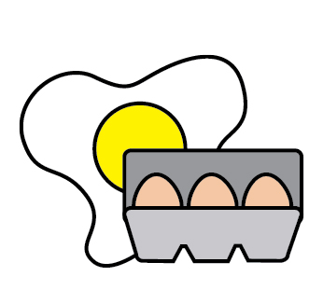 | 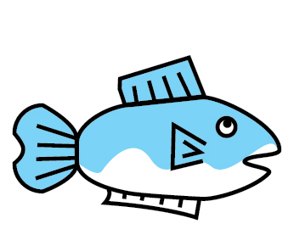 | 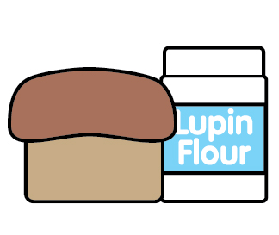 | 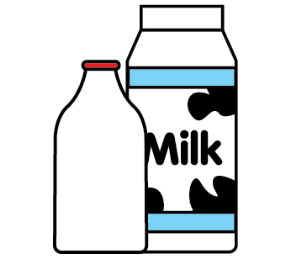 |  | 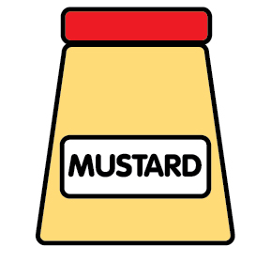 | 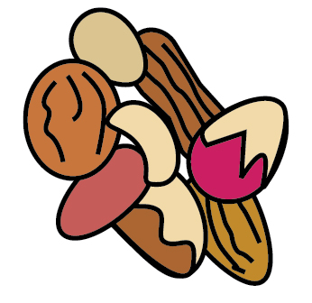 | 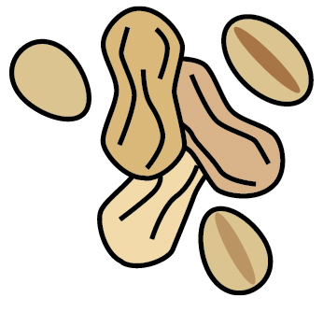 | 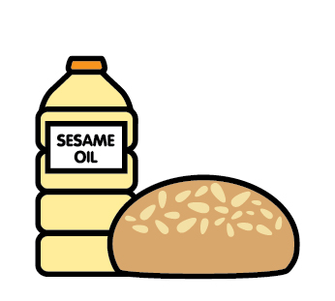 |  | 
 | Celery | Cereals containing gluten | Crustaceans | Eggs | Fish | Lupin | Milk | Mollusks | Mustard | Nuts | Peanuts | Sesame seeds | Soya | Sulphites
MAIN MEALS
Margherita Pizza (Mix) |  | ✓ |  | ✓ |  |  | ✓ |  |  |  |  |  | ✓
Margherita Pizza (Base) |  | ✓ |  |  |  |  | ✓
Pasta Bolognaise |  | ✓
Tri Colour Pasta |  | ✓
Sausages |  | ✓
GF Sausages
(Westaway)
Yorkshire Pudding |  | ✓ |  | ✓ |  |  | ✓
Spanish Chicken |  |  |  |  |  |  | ✓
Chorizo Small Packs |  |  |  |  |  |  | ✓ |  |  |  |  |  | ✓
Breaded Fish Fillet |  | ✓ |  |  | ✓
GF Fish Fingers |  |  |  |  | ✓
Mac Cheese |  | ✓ |  |  |  |  | ✓ |  | ✓
GF Mac Cheese |  |  |  |  |  |  | ✓ |  | ✓
Garlic Bread |  | ✓ |  |  |  |  | ✓ |  |  |  |  | ✓
Chicken, Ham & Leek Pie |  | ✓
Roast Chicken
Stuffing |  | ✓
Gravy
Beef Lasagne |  | ✓ |  |  |  |  | ✓
Salmon Bites (Nuggets) |  | ✓ |  |  | ✓
Cheese Quiche |  | ✓ |  | ✓ |  |  | ✓ |  | ✓
Chicken & Butternut Curry
Gammon & Pineapple
Hot Dog Bun |  | ✓ |  |  |  |  |  |  |  |  |  | ✓
Sausage |  | ✓
VEGGIE MEALS
Falafel Wrap |  | ✓ |  | ✓
Bean Chilli
BBQ Quorn Strips |  |  |  | ✓
Super Doodle Noodles |  | ✓ |  | ✓
Katerveg Vegan Sausage Roll |  | ✓
Vegan Sausage |  |  |  |  |  |  |  |  |  |  |  |  | ✓
Cheese Pizza Baguette |  | ✓ |  |  |  |  | ✓ |  |  |  |  | ✓
Lentil Loaf  (Osprio Lentils) |  |  |  | ✓
Cheese & Red Onion Wheel |  | ✓ |  | ✓ |  |  | ✓ |  | ✓
Veggie Nuggets |  | ✓
Sweet Pepper & Sweetcorn Pasta |  | ✓ |  |  |  |  | ✓
Quorn Stir Fry with Noodles |  | ✓ |  | ✓ |  |  |  |  |  |  |  |  | ✓
Quorn Stir Fry with Rice |  |  |  | ✓ |  |  |  |  |  |  |  |  | ✓
Summer Veg Crumble |  | ✓ |  |  |  |  | ✓
Finger Roll |  | ✓
DESSERTS
Pancakes & Syrup |  | ✓ |  | ✓ |  |  | ✓
Fruit Jelly
Frozen Yoghurt |  |  |  |  |  |  | ✓
Fruit Smoothie
Iced Farmhouse Cake |  | ✓ |  | ✓ |  |  |  |  |  |  |  |  | ✓ | ✓
Fruity Flapjack |  | ✓
Fruit Platter
Pineapple Cake |  | ✓ |  | ✓ |  |  |  |  |  |  |  |  | ✓
Milkshake |  |  |  |  |  |  | ✓
Orange/Apple Juice
Chocolate & Blueberry Cake |  | ✓ |  | ✓ |  |  | ✓ |  |  |  |  |  | ✓
Summer Fruit Pots |  | ✓ |  |  |  |  | ✓
ABC Cake |  | ✓ |  | ✓ |  |  |  |  |  |  |  |  | ✓ | ✓
Ice Cream Pots |  |  |  |  |  |  | ✓
Chocolate Brownie |  | ✓ |  | ✓ |  |  | ✓ |  |  |  |  |  | ✓
Choc. Date Biscuit |  | ✓ |  | ✓ |  |  |  |  |  |  |  |  | ✓
Ginger Biscuit |  | ✓ |  |  |  |  |  |  |  |  |  |  | ✓
Anzac Biscuit |  | ✓ |  |  |  |  | ✓ |  |  |  |  |  | ✓
Lemon Biscuit |  | ✓ |  | ✓ |  |  |  |  |  |  |  |  | ✓
PACK LUNCHES
Egg Mayo Sandwich |  | ✓ |  | ✓ |  |  |  |  |  |  |  |  | ✓
Ham Sandwich |  | ✓ |  |  |  |  |  |  |  |  |  |  | ✓
Tuna Wrap |  | ✓ |  | ✓ | ✓
Sausage Roll |  | ✓ |  |  |  |  | ✓
Salmon, Mayo Wrap |  | ✓ |  | ✓ | ✓
Tuna Mayo Bap |  | ✓ |  | ✓ | ✓ |  |  |  |  |  |  | ✓
Cheese Bap |  | ✓ |  |  |  |  | ✓ |  |  |  |  | ✓
Egg, Mayo Lettuce Sandwich |  | ✓ |  | ✓ |  |  |  |  |  |  |  |  | ✓
Pizza Muffin |  | ✓ |  |  |  |  | ✓ |  |  |  |  |  | ✓
Cheese & Tom. Sandwich |  | ✓ |  |  |  |  | ✓ |  |  |  |  |  | ✓
Tuna, Mayo Cucumber Wrap |  | ✓ |  | ✓ | ✓
Ham Bap |  | ✓ |  |  |  |  |  |  |  |  |  | ✓
SIDES
Pre Peeled Potatoes
Tuna Mayo |  |  |  | ✓ | ✓
Baked Beans
Cheese |  |  |  |  |  |  | ✓
Malted Baguette |  | ✓ |  |  |  |  |  |  |  |  |  | ✓
Coleslaw |  |  |  | ✓
Wholemeal Bread |  | ✓ |  |  |  |  |  |  |  |  |  |  | ✓

