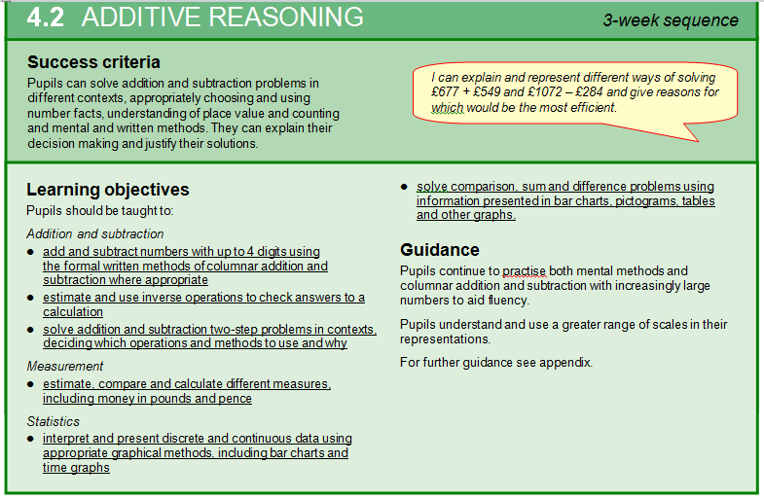

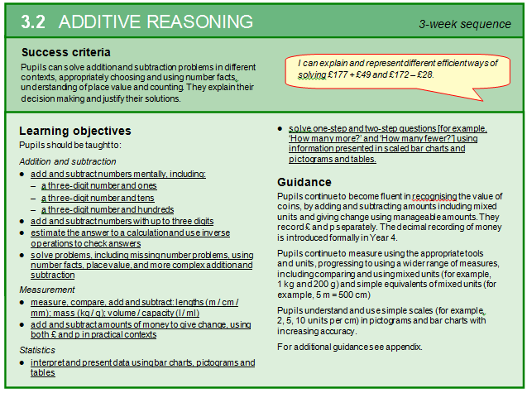

(Page 1)

***Symbols***

***Symbols***

**1**

**Page 1:- QUESTION: a) I can explain and represent different ways of solving £177 + £49 and £172 -£28 What images and resources might you use to solve this?**

**2**

*n/d ÷ +, x -, ²,˚*

Add, subtract, place value, tens, hundreds, thousands, tenths, hundredths. Numeral, inverse, more than, less than, money, pounds, pence, rounding, decimal place, 100 square, 200 square

Elicitation activity – 3.2, 4.2

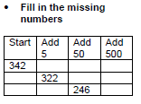

Mental fluency - 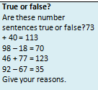



***Language******Mathematical***

**3**

***image / picture***

**Mental Fluency:-** 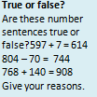

**Model :-Numberline method to +Partitioning method**

**Year 3 2 digit by 2 digit, 3 digit by 2 digit. Year 4 any numbers.**

, number line, Cuisenaire, ruler, Diennes, counters,

Use connective model

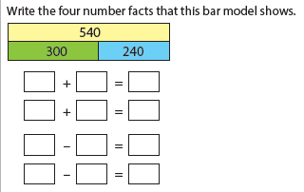

House process, value of a number, weight, length money

Shopping change estimation

***Context***

**: When you add 7 to any number you always partition it into 5 + 2. Is it always, Sometimes, never True?**

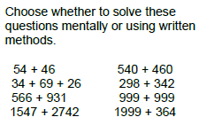

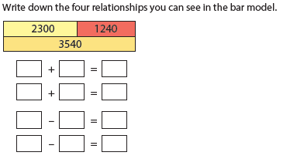

Generate numbers to add – use counters for support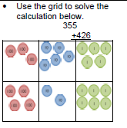

**HA**

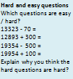 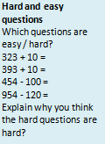

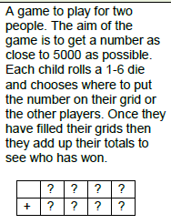

**HA**:- Convince me!

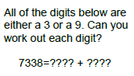

**HA:-** 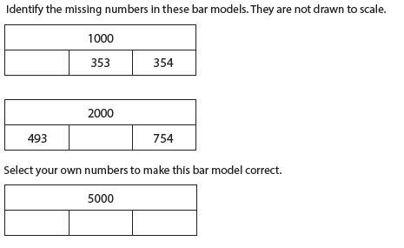

**Handwriting:- Refer to the inverse calculation when calculating.**

1. **Fluency – Mental fluency - Yr 3 3 digit number + or – tens and 1’s, 3 digit number +, - 10’s, 100’s. Yr 4 use 4 digit numbers. (THREAD THROUGHOUT TEACHING WHERE POSSIBLE)**
2. **Reasoning – proving number sentence is true or false. Check using inverse.**
3. **Solve problems mentally and written**
4. **4. Talk - dialogic language, explaining strategies and solutions.**

*Page 2*

**Session 8, 9 Measure, length, weight, money**

**Session 7 – Use inverse to check – use + and – to solve problems**

**4 / 5/ 6 Written formal methods to + and -**

**Session 10 discrete and continuous data graphs**

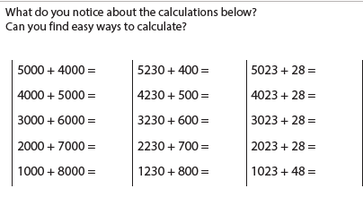

**Final Assessment task (end elicitation)**

Solve problems involving money and measure

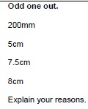

HA-

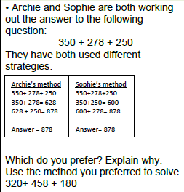

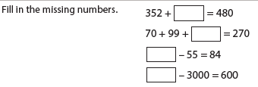

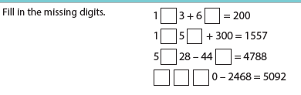

**Measure and represent data.**

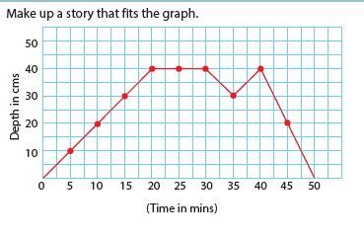

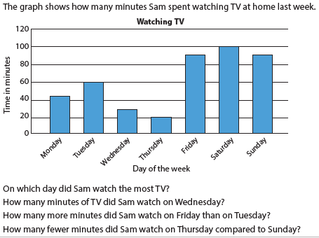

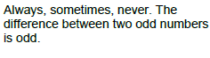

Move to formal written methods

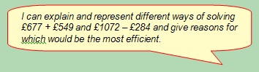

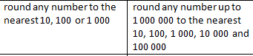 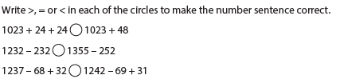

**HA:-**

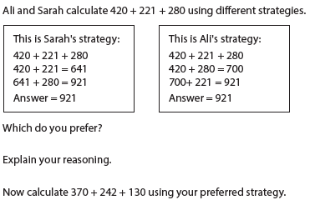

Use Place value counters for addition and subtraction

Commutative law – the order of numbers in an addition calculation makes no difference

**Convince me! It does matter which order you calculate an addition or subtraction calculation ( True or False)**

Associated law – if you have 3 or more numbers to add it makes no difference whether you add the first or second number.

**Always, Sometimes, Never true :- Is it Always, sometimes, never true that when adding numbers together it doesn’t matter which order you add them.**

**Is it always sometimes never true that the different between two odd numbers is odd.**

**Is it always, sometimes, never true when you add 2 odd numbers the answer is odd and when you add to even numbers the answer is even.**

**Mental maths Ideas:-**

**Bonds to 10,100, 1000 –**

**Times table practice –**

**Add and subtract numbers mentally**

**3 digit/4 digit + or – 10’s or 1’s**

**3 digit/4 digit + or – 100’s**

**Guided groups:-**

**( Guided maths book:-**

**Dart board totals**

**Calculation walls – p 56**

**Nice and nasty**

**Out**