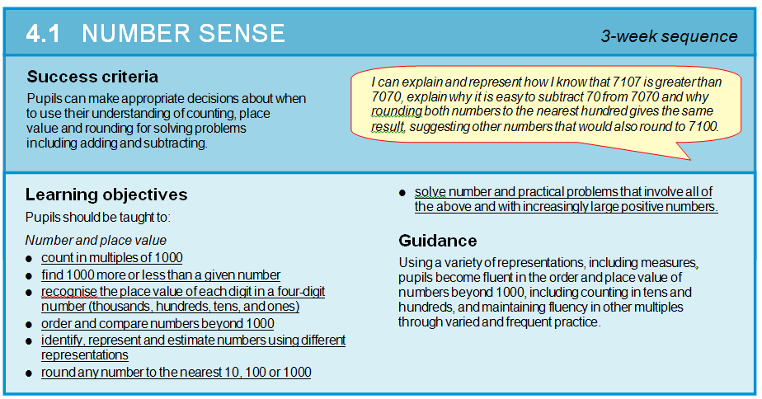

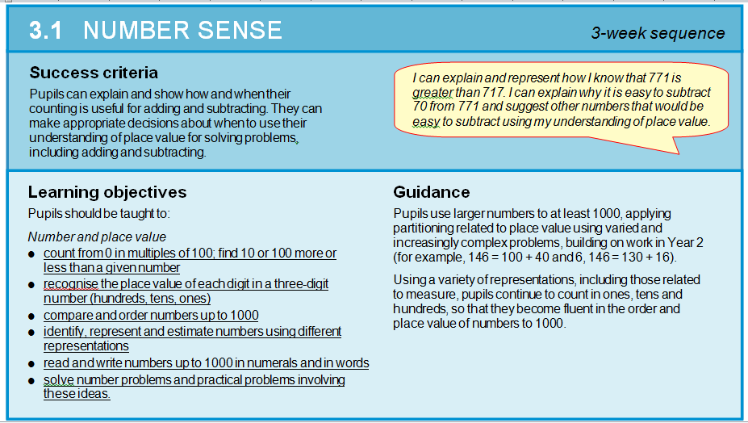

(Page 1)

***Symbols***

***Symbols***

**2**

*n/d ÷ +, x -, ²,˚*

Add, subtract, place value, tens, hundreds, thousands, tenths, hundredths. Numeral, inverse, more than, less than, money, pounds, pence, rounding, decimal place, 100 square, 200 square

**Page 1:- QUESTION: a) If you have two or more 3 digit numbers how do you know which is greater or has more value? What images and resources might you use to solve this?**

**1**

Elicitation activity – 3.1, 4.1

Use digit flips for quick fire place value recognition up to 1000

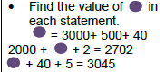

***Language******Mathematical***

**3**

**BLOCK NUMBERS** Partitioning a number into its constituent parts – H, T, U (Y3), Th,H,T U (Yr 4) Use models and images to support this.

***image / picture***

**Compare and order numbers up to and beyond 1000 – quick fire 10 more, less, 100 more less etc**

, number line, Cuisenaire, ruler, Diennes, counters,

**Main:- Always, Sometimes, Never :**

**“A number can only be written**

**In 1 way.**

Use connective model

***Context***

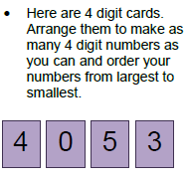

House process, value of a number

Shopping change estimation

**hth, tth, th, h, t, 0 model**

**Recognise the value of digit. What is the value now?**

**HA:** 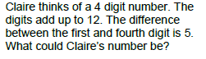

Comparing and ordering numbers. Play the nice and nasty game with a partner. Using a dice where is the best place to put a digit to make the biggest number.

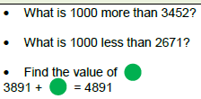

Yr 3 100 more less

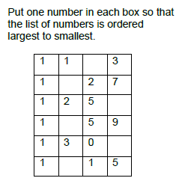

Main: Roll dice 1000 more less:

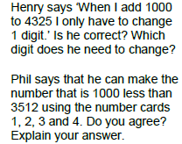

**HA**:- 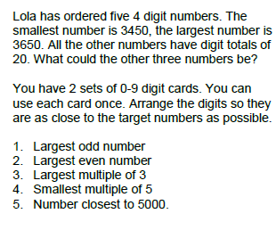

**HA:-**

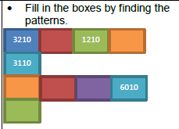

1. **Fluency – counting from 0 in multiples of 10, 100,1000. Recognise the value of a 2,3,4 digit number**
2. **Reasoning – proving the value of a digit and number. Include decimals**
3. **Solve problems**
4. **4. Talk - dialogic language, explaining strategies and solutions.**

**Handwriting:-**



*Page 2*

**Sesson 5 and 6 - Rounding numbers**

Adding 10, subtracting 10 from a number. Adding 11, subtracting 11 from a number.

**4 -Decimal numbers**

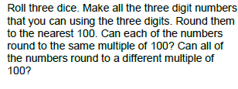

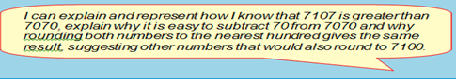

**Final Assessment task**

HA- 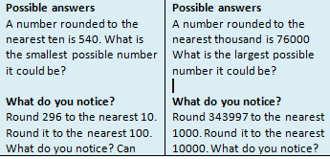

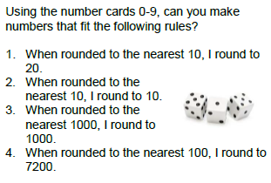

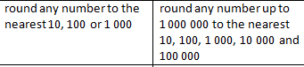 

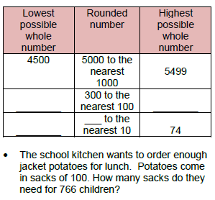

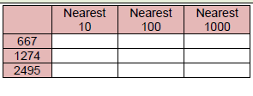

Round numbers to the nearest 10, 100, 1000. Rounding bingo, p 68.

HA:-

Investigate the difference between data.

“ What is the difference between 1st and 7th result?

Olympics Measure

Order sprint data etc according to size. Who is 1st? Who cam 7th?

“A number with 1 decimal place is smaller than a whole?” How do you know?

**Mental maths Ideas:-**

**Quick fire using digit flips the value of a number**

**Place value bingo**

**Counting in steps 10, 100, 1’s**

**Counting in 0.5, 0.2, 0.3 0.4**

**Bonds to 10,100, 1000 – generate facts for free, how far can they go.**

**Times table practice – chanting, Times table challenge, Using the counting stick**

**Always, Sometimes, Never true :-**

A number with 5 hundreds is bigger than a number with 3 hundreds.

A number with one decimal place is smaller than a whole number.

**Fluency:-**Use digit flips to identify the place value of a number.

**Guided groups:-( Guided maths book:-**

**Guided maths – totally odd cards (p48)**

**Calculation walls – p 56**

**Polite numbers – guided maths p 16**

**Out**